Visual arts: External assessment production

input.doc

General information
This document contains information for the external assessment of the production component in Visual Arts.

In 2010, all Year 12 students enrolled in at least two Stage 2 or two Stage 3 units in the Visual Arts course will be required to submit work to receive marks for the production component of the external examination.

The Curriculum Council will supervise and conduct the external assessment of work submitted by students undertaking Stage 2 and Stage 3 units. This will take place in a centralised metropolitan location, ensuring standardised conditions and marking comparability.

Further advice on matters related to the administration of Curriculum Council assessment will be published in the Curriculum Council WACE circular. Teachers should also refer to the TEE/WACE examination policy published in the WACE manual and on the Curriculum Council website.

Teachers are responsible ensuring the syllabus requirements are meet this includes following the Curriculum Council assessment guidelines and making sure the materials the external examination conform with the specifications. Teachers must ensure they are using the currently accredited course.

External examination weightings
In Visual Arts the external examination weightings are as follows:

Artwork (production) 50%
Written examination paper (2.5 hours) 50%

Reporting achievement
For each unit, schools will be required to submit a mark out of 100 to the Curriculum Council. The school course mark will be calculated by the Curriculum Council by averaging the mark out of 100 for the two units studied in Year 12. The examination mark (a combination of the practical component and the written component) will statistically moderate the school course mark. In 2010, the Curriculum Council will report a WACE course mark which is determined from the moderated school course mark and the standardised examination mark. For the purpose of ranking students for tertiary entrance, the average of the moderated school course mark and the standardised examination mark will be scaled.

Principles
1. The marking process preserves the anonymity of the candidate and the candidate’s school.
This requires that:
- candidates and their work will be identified only by their randomly allocated student number.
- marking occurs in central locations where the work can be displayed and not be identified with a particular candidate or school.

2. The authenticity of the candidate’s work must be guaranteed.
It is essential that:
- the main development of work takes place in school time.
- work completed away from the school is regularly monitored by the teacher.
- each student signs a statement*, witnessed by the supervising teacher and the principal, that the work is genuinely his or her own.
- under no circumstance can any teacher work directly on any part of a student’s work that is submitted for external assessment.
- a candidate must not submit the same piece of work in more than one course.

*Form to be provided see sample in Appendix 3.

3. Markers will apply a consistent standard to assess the candidate’s work.
This requires:
- separate marking guides for Stage 2 and Stage 3 units.
- attendance at a training meeting prior to the commencement of marking.
- trial marking of work to ensure a common understanding of the marking guide.

4. Double marking of candidate’s work will be carried out.
This requires that:
- each marker marks the work independently.
- where necessary, the Chief Marker will reconcile significant differences.
- the Chief Marker will ensure marking consistency throughout by monitoring the marking process.
- marking of production examinations will be concluded prior to the commencement of the written examinations.

External production examination requirements
For the purposes of fairness and equity the following options regarding size and weight of submitted works must be adhered to. Candidates are to submit work for assessment in one of the following categories listed below:

Category 1
Compete submission must not exceed two and a half square metres (2.5sqm) when displayed for marking

OR
Category 2
Complete submission must not exceed 1.5 cubic metres in volume or 34.4kg in weight when packed for marking. Note: flat, two-dimensional works may also accompany works submitted in this category.

OR
Category 3
Complete submission must not exceed four minutes in duration and be submitted in DVD format compatible with PC or Mac

Important:
Teachers are encouraged to assist students in the refinement of their choices. When selecting works for submission, work must be confined to the designated size and weight dimensions specified. Students should select works that demonstrate their highest achievement in the Production Assessment Type (Outcome 1 and Outcome 2). Works that do not conform to size requirements stipulated will be considered invalid and will not be marked.

Procedures for Submission

Advice to schools
Works submitted for external assessment must not be offensive or dangerous. While it is understood that submitted works may challenge established views, it is important to consider and take into account the values of the audience and wider community in general.

All care should be taken to ensure works are safe for handling and not contain sharp or dangerous materials, such as needles, broken mirror or barbed wire. All works requiring electrical connection must be certified by a qualified electrician.

Works submitted for external assessment should be stable and of sound construction to avoid unnecessary damage.

Damage to works
Some works may be damaged in transport or as a result of handling during the marking process. Teachers and candidates should note that minor damage does not affect the marking process. Insurance is the school’s responsibility.

Labelling of candidate’s work
Candidates and their school must ensure that all works:
- are clearly and securely labelled with the Curriculum Council’s student number.
- do not contain the candidate’s name or names of persons associated with the candidate’s school or family.
Works that can be identified, or do not comply with the above submission guidelines may incur marking penalties, or may be rejected from the marking process at the discretion of the Chief Marker.

Deadline for submission of materials
All materials must be received at the marking venue by the final date determined by the Curriculum Council so that marking can commence on the first weekend of Term 4.

Works submitted after the published date and time will not be marked. Individual candidates who were unable to submit their works due to illness or an unforeseen situation can submit a sickness/misadventure application form.

Submission Requirements
A candidate’s submission must include:
- The Resolved artwork

Artworks submitted may take a variety of forms (see Appendix 1—Art forms) including:
- individuals works
- works that are linked either conceptually or materially
- The Artist’s statement (as shown in Appendix 2—Sample form for Resolved Artwork).
- A declaration of authenticity ( as shown in Appendix 3)
- a photograph of their completed work/s for submission, as it would be displayed, attached to the artist statement (this applies to categories 1 and 2 only).

Artworks submitted must be selected from the last two units studied by the student and may take the form of individual works or works that are linked either conceptually or materially. Items for external assessment need not be framed or include any unnecessary display materials

The Artist’s statement
The artist’s statement is a concise explanation of the resolved artwork, no more than 300 words in length. The artist’s statement will explain the rationale for conceptual and material development and realisation of ideas and artworks. A standard proforma as per sample page 8 of this booklet will be provided to candidates.

The artist’s statement will be read in conjunction with submitted artworks. The artist statement is expected to support assessment of Outcome 1 (Arts Ideas). It will not be assessed as it serves to provide the clarification of ideas communicated in resolved work.

Declaration of authenticity forms for external assessment
Signed authentication forms, artist statement, photographs of submitted works (for categories 1 and 2) are to be provided with a candidate’s submitted work. Under no circumstances may works identify the candidate or their school.

Each private candidate completes the declaration form in the presence of a commissioner of declarations. Each candidate undertaking the external assessment production must provide the appropriate paperwork and signed forms. These forms must accompany the work in a separate manilla envelope or folder but must not be attached to the work. A sample of this authentication form is provided in Appendix 3 of this booklet.

Teachers will need to ensure that copies of authentication forms are kept with school records, for verification in the event of loss during transportation to the Curriculum Council. Authentication forms act as legal documents and therefore proper records need to be maintained.

Documentation of thinking and working practices
In all cases where student work is submitted for external assessment, schools must keep records of the thinking and working practices that lead to the development of the student’s submitted work. The Curriculum Council may, during or after the examination process, call upon the documentation of thinking and working practices to substantiate the authenticity of a student’s work that is submitted for final assessment.

Copyright acknowledgement

As direct use of stimulus material or copying of another person’s work without proper acknowledgment is not permitted candidate’s must acknowledge all copyright.

Marking

Transport of artworks to venues for external marking

The Curriculum Council marking process will commence on the first weekend of Term 4.
Schools will be notified by the Curriculum Council of final date for submission and location for marking. Schools are responsible for ensuring works are packed and prepared for transportation to the Curriculum Council by the nominated date.

The Curriculum Council is responsible for the cost of transporting artworks to and from the venue. However, where materials are not ready for the Curriculum Council carrier by the designated time, schools will be responsible for all associated transportation costs and ensuring the material arrives at the designated examination venue location by the due date. No late artwork can be accepted.

Schools are responsible for the packaging and insurance of works against damage in transit.

All submitted works are to be accompanied with the appropriate paperwork and signed forms.

Appointment of markers
The Curriculum Council will appoint a Chief Marker who will be responsible for the external assessment process and training. Teachers may apply to be external markers. External markers are employed by the Curriculum Council and are therefore responsible to the Curriculum Council through the Chief Marker.

The Curriculum Council will allocate, in consultation with the Chief Marker, a set number of works per marker. These works will be randomly allocated according to the candidate’s Curriculum Council student number.

The marking process
The markers will work collaboratively with the Chief Marker and under the direction of the principles of external assessment defined by the Curriculum Council.

The Chief Marker sets the standards and this will be based strictly on the criteria set down in the marking guidelines. Exemplar materials will be selected by the Chief Marker and used to exemplify standards and levels of production achievement.

Marking of the work will be undertaken by two independent markers.

A numerical scale will be used to assess student’s production in terms of:
- creativity and innovation
- skills and processes
- use of visual language
- use of media
- communication of ideas

See sample marking keys in Appendices 4 and 5.
Judgements will be compared and a process of reconciliation will be undertaken under the direction of the Chief marker.

All independent marks and reconciled marks will be recorded and submitted to the Curriculum Council by the Chief Marker.

The Chief Marker will be required to prepare a formal written evaluation report which will be based upon the established Curriculum Council criteria of:
      - adherence to protocols and processes
      - attention to administrative processes
      - implementation and adherence to established production standards for the subject
      - other relevant comments.

Confidentiality of student marks is vital and must not be breached. External markers must not be involved in the marking of students from their own school and must immediately disclose if they recognise a candidate’s work.

APPENDIX 1

Art forms

Artworks submitted may take a variety of forms, including:
- individuals works
- works that are linked either conceptually or materially.

Students are to submit artwork that may contain one, or a number of works in the following forms:

Drawing | Approaches to drawing range greatly from traditional forms of representation to more experimental approaches.
Painting | There is a broad range of possible approaches to painting ranging from traditional to experimental.
Printmaking | Involves the process of transferring marks and images from one surface to another. Both traditional and contemporary approaches may be explored.
Graphic design | The organised communication of messages for particular contexts and purposes.
Photography | May include traditional and digital approaches.
Film, video, digital works and animation | Works which may include still and moving images.
Sculpture | There is a broad range of possible approaches to sculpture, ranging from traditional to experimental
Ceramics and glass | The manipulation of ceramic and glass materials for any purpose.
Textiles and fibre | The expressive manipulation of materials and fibre to create works in any dimension.
Designed objects/ environments/ jewellery | This may include wearables, architectural models, and industrial design and products.
Interactives | This is a growing field of art making which explores the interactive nature of media and audience.
Documented forms/ installation/ site-specific | These art forms relate to artworks or events that cannot be submitted. Examples may include performances, site-specific artworks or those lasting for only a short amount of time. These artworks need to be documented in an appropriate format.
Costume and stage design | These art forms relate to events for stage and performance.
Collection of works | A range of thematic art forms presented as a collection of works.
Mixed media | Combining a range of media.

APPENDIX 2

Artist statement—resolved artwork

Instructions to candidates
An artist’s statement is a concise explanation of your resolved artwork.

In your statement you should consider including the following:
- a reflection on your thinking journey and the creative processes of your art experiences.
- the key decisions you made, acknowledging contextual and other influences on your work.
- a reflection on the purpose, intent and meaning of your work, and how these relate to your personal point of view.

In a statement of 300 words or less, describe your final resolved artwork.

Student number:

Category: |  | Photograph attached:
 |  | (not required for category 3)

Copyright and References Acknowledgements
All Copyright and use of other persons work or materials used in the submitted works are to be clearly referenced in this section.

APPENDIX 3: Sample form for Resolved Artwork

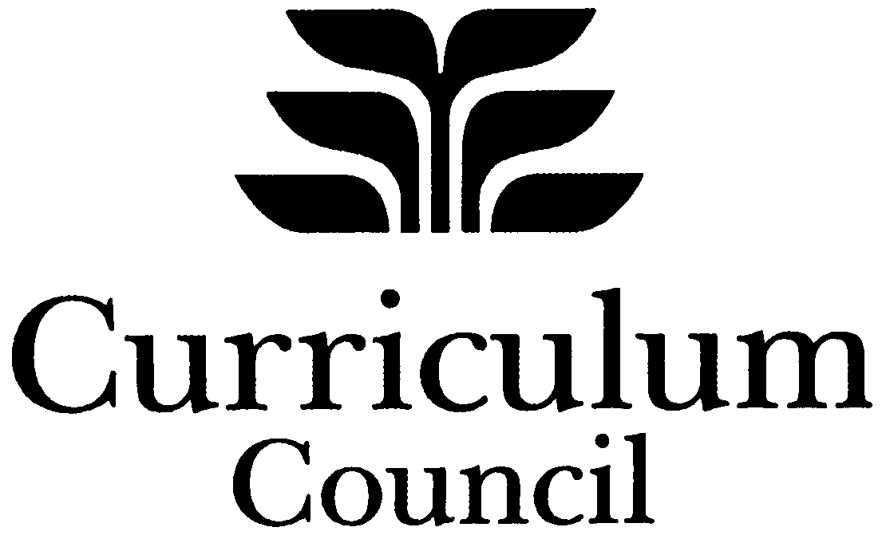



DECLARATION OF AUTHENTICITY
2010 External Assessment Production

CANDIDATE DECLARATION
Name: |  | School code:

Student number:
Category:

As a candidate for the Visual Arts examination in 2010, I declare that all the work submitted was completed by me during 2010, and that, to the best of my knowledge, all the information provided is correct and all references have been acknowledged on the artist statement.
Signed: |  | Date:

Please note:
- To maintain anonymity, this declaration form must accompany but must not be attached to the submitted art work.
2. All copyright and secondary visual materials used in the submitted works must be clearly referenced on the artist statement form.

WITNESS DECLARATION

SCHOOL CANDIDATES
(to be completed by your teacher and school principal: your work will not be marked if the declaration is not signed)

Teacher and principal declaration
I declare that, to the best of my knowledge:
- the work contained in this submission was completed in 2010;
- the main development occurred in school time, with regular monitoring of work away from school; and
- no teacher or any other person has worked directly on the student’s work.
Teacher signature: |  | Date:
Principal signature |  | Date:

PRIVATE CANDIDATES
(a Commissioner of Declarations needs to witness your signature and complete this section)

Commissioner of Declarations
Name:
Address:
Signed: |  | Date:

APPENDIX 4: Sample Marking Key

Stage 2 marking guidelines (production)

Creativity and innovation
10–9 | 8–7 | 6–5 | 4–3 | 2–1
Work is strong and ambitious demonstrating originality, creativity and flair. | Work is expressive and shows a sound level of creativity and originality. | Work is imaginative and shows some elements of creativity and originality. | Work is very basic showing limited creativity and originality. | Work unoriginal, and lacks engagement.
Score:
Communication of ideas
10–9 | 8–7 | 6–5 | 4–3 | 2–1
Ideas successfully communicated in articulate and expressive work. | Ideas effectively communicated in direct and uncomplicated work. | Literal, obvious or superficial ideas communicated. | Limited ideas communicated. | Ideas insufficiently or ineffectively communicated.
Score:
Use of visual language
10–9 | 8–7 | 6–5 | 4–3 | 2–1
Highly developed application of visual language demonstrated in artwork. Successful visual relationships evident. | Competent application of visual language demonstrated in artworks. Sound visual relationships evident. | Simple application of visual language demonstrated in artwork. Few visual relationships evident. | Minimal application of visual language demonstrated in artwork. Unsuccessful visual relationships evident. | Weak application of visual language demonstrated in artwork.
Score:
Use of media
10–9 | 8–7 | 6–5 | 4–3 | 2–1
Highly competent selection and use of media demonstrating consistent application and handling. | Appropriate selection and use of media demonstrating satisfactory application and handling. | Basic selection and use of media demonstrating sufficient application and handling. | Minimal selection and use of media demonstrating inappropriate application and handling. | Insufficient exploration and use of media demonstrating poor application and handling.
Score:
Skills and processes
10–9 | 8–7 | 6–5 | 4–3 | 2–1
Highly considered selection and application of skills and processes used to resolve work. | Appropriate selection and application of skills and processes used to resolve work. | Limited selection and application of skills and processes used to resolve work. | Inappropriate selection and application of skills and processes used to resolve work. | Poor selection and application of skills and processes used to resolve work.
Score:

Total marks /50
APPENDIX 5: Sample Marking Key

Stage 3 marking guidelines (production)

Creativity and innovation
10–9 | 8–7 | 6–5 | 4–3 | 2–1
Work is outstanding, shows exceptional creative thinking and exhibits a distinctive personal style. | Work is strong and ambitious demonstrating originality, creativity and flair. | Work is expressive and shows a sound level of creativity and originality. | Work is imaginative and shows some elements of creativity and originality. | Work is very basic showing limited creativity and originality.
Score:
Communication of ideas
10–9 | 8–7 | 6–5 | 4–3 | 2–1
Ideas skilfully communicated in sophisticated and highly coherent work. | Ideas successfully communicated in articulate and expressive work. | Ideas effectively communicated in direct and uncomplicated work. | Literal, obvious or superficial ideas communicated. | Limited ideas communicated.
Score:
Use of visual language
10–9 | 8–7 | 6–5 | 4–3 | 2–1
Extensive and sophisticated application of visual language demonstrated in artwork. Complex visual relationships evident. | Highly developed application of visual language demonstrated in artwork. Successful visual relationships evident. | Competent application of visual language demonstrated in artworks. Sound visual relationships evident. | Simple application of visual language demonstrated in artwork. Few visual relationships evident. | Minimal application of visual language demonstrated in artwork. Unsuccessful visual relationships evident.
Score:
Use of media
10–9 | 8–7 | 6–5 | 4–3 | 2–1
Highly refined selection and use of media demonstrating sensitive application and handling. | Highly competent selection and use of media demonstrating consistent application and handling. | Appropriate selection and use of media demonstrating satisfactory application and handling. | Basic selection and use of media demonstrating sufficient application and handling. | Minimal selection and use of media demonstrating inappropriate application and handling.
Score:
Skills and processes
10–9 | 8–7 | 6–5 | 4–3 | 2–1
Informed selection and excellent application of skills and processes used in resolving work. | Highly considered selection and application of skills and processes used in resolving work. | Appropriate selection and application of skills and processes used in resolving work. | Basic selection and application of skills and processes used in resolving work. | Inappropriate selection and application of skills and processes used in resolving work.
Score:

Total marks /50

